Introduction to Deep Learning
Tutorial 7
Convolutional Neural Networks
- The convolutional neural network (CNN, or ConvNet) is probably the most widely used deep learning neural network.
- CNN is mainly used for image analysis, e.g., image classification, object detection, and image segmentation.
- It can also be used in recommendation systems, natural language processing, brain-computer interfaces, and financial time series.
- To date, a number of CNNs have been developed, such as LeNet, AlexNet, GoogLeNet (now Inception), VGG, ResNet, DenseNet, MobileNet, EffecientNet, YOLO, and so on.
- An architecture of convolutional neural network that contains an input layer, convolutional layers, pooling layers (subsampling, or down sampling), activation layers, fully connected layers, and an output layer.

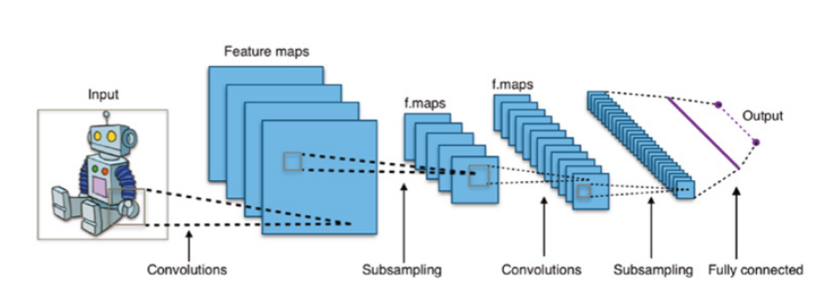
- Input Layer: This is the layer that takes images as input. It typically has a size of 32 × 32 × 1 for handwriting digit images in grayscale, and 224 × 224 × 3 for color photo images.
- Convolutional Layer: This is the core structure of a convolutional neural network. It uses feature filters (also called kernels) to extra feature information from the input. In figure, some commonly used image filters, or image kernels, that can perform sharpening, blurring, and edge detection of an input image. It shows the convolution process of an image and a kernel. The convolution process is essentially to multiply the image matrix values with kernel values as an element-wise product and then add all the values to get the convoluted results.
- Pooling Layer: Pooling layer is another core structure of CNN. The pooling layer is used for downsampling. Max pooling is the most commonly used pooling. As shown in figure, max pooling divides the input image into a series of nonoverlapping rectangles and outputs the maximum for each of these subregions. In this example, a 4 × 48 × 8 image has been mapped by a 2 × 2 window with the stride or compression size of 2. Within the 2 × 2 window, each region (2 × 2) is collapsed into a single pixel by choosing the maximum value. In this way, the entire 4 × 4 image is downsampled into a 2 × 2 image. Another commonly used pooling is average pooling.
- Activation Layer: The activation function of a node defines the output of that node as a function of an input or a set of inputs. There are three commonly used activation functions: REctified Linear Unit (ReLU), hyperbolic tangent, and sigmoid function. In deep learning, ReLU is often preferred because it makes neural network training much faster

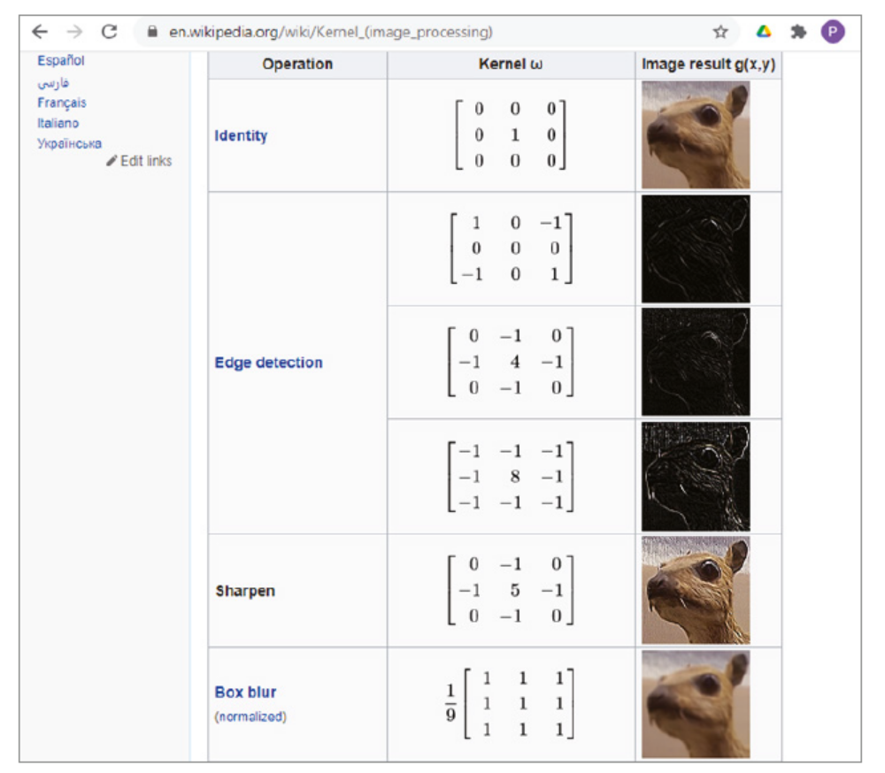
- Fully Connected Layer: After several convolutional layers and max pooling layers, the high-level reasoning in the neural network is done via fully connected layers. The neurons in a fully connected layer have connections to all activations in the previous layer, as shown in regular (non convolutional) artificial neural networks. Fully connected layer is also called dense layer.
- Dropout Layer: The dropout layer drops out some of nodes in the neural network to prevent overfitting. Dropout layer can be used with most types of layers, typically after the fully connected layer.
- Output Layer: This layer gives the final output of the CNN. For classification, neural networks the number of outputs depends on the number of classes. For regression neural networks, there is only one output that is a floating-point number, a number with a decimal point.
